TASK 2

Inference

* In task 2 ARMA model is used the predict the final forecasting output
* Before the forcasting after finding the seasonality and trend , the stationarity of the data is checked by using rolling mean and standard deviation and ADF(augumented dickey fuller test)

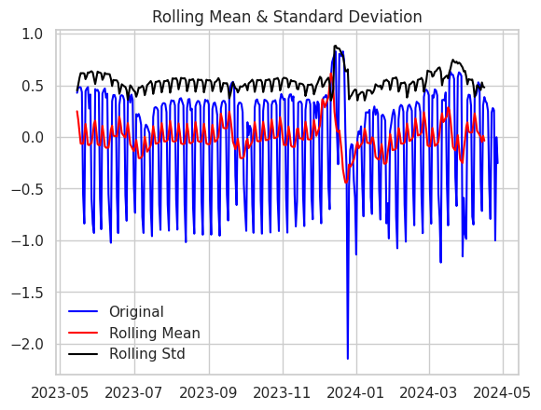

* Next transformation techniques like log,difference and log-differencing techniques are used

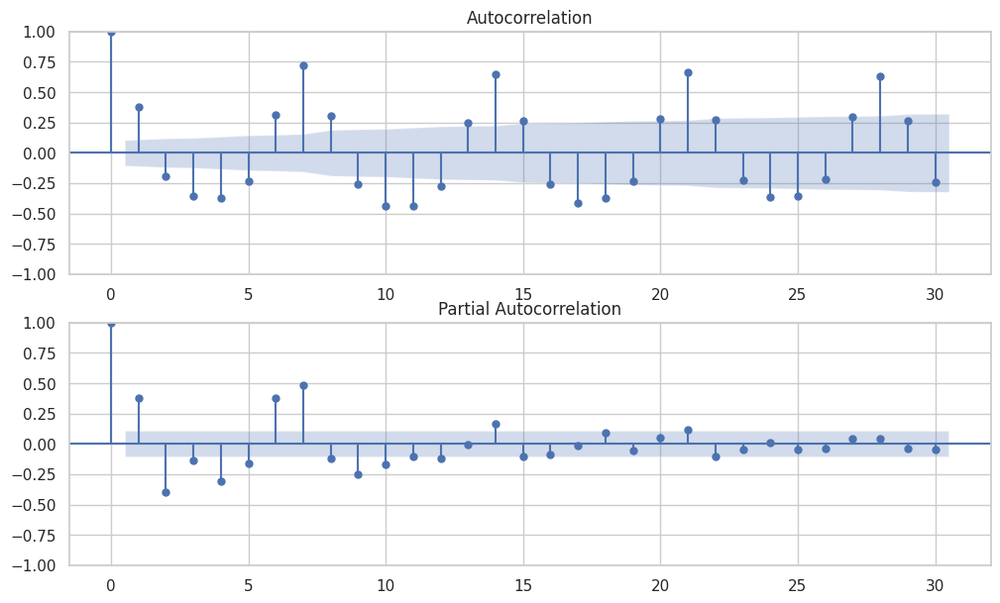

Final prediction result using ARMA

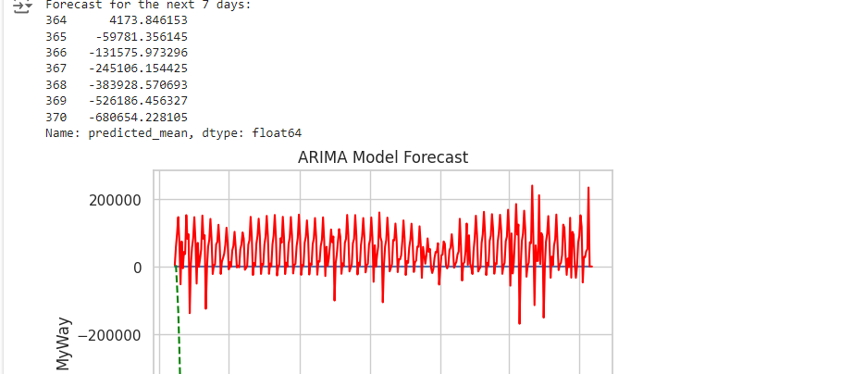

Inference :

The output of model for next 7 days prediction is not as expected and the enhancement need to done

Such as transformation etc.., .